CHANGES HISTORY
PIC | Date | Remarks
SIMPI.GRA | 2018.12.143 | Created

TOC
- mail_queue
- mail_attachment
- mail_setting_attachment
- mail_setting_sender
- mail_setting_simpi
- notification_queue
- notification_setting
- notification_user
- system_access_api
- system_api
- system_application
- Diagram ENTITY RELATIONSHIP

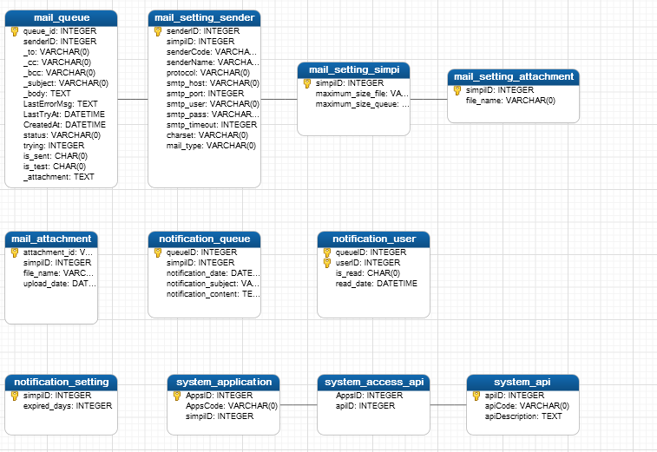
TABLE RELATIONSHIP
No | Table 1 | Table 2 | Type (1:1; 1:N; M:N) | Description
1. | mail_queue | mail_setting_sender | N:1
2 | mail_setting_sender | mail_setting_simpi | N:1
3 | mail_setting_simpi | mail_setting_attachment | 1:N/0
4 | system_application | system_access_api | 1:N/0
5 | system_access_api | system_api | N/0:1

Name |  | mail_queue
Objective
No | Column |  | Type | Rule  (PK, FK, Key, NN, Unik, Index) | Description
1 | queueID |  | integer(11) | PK
2 | senderID |  | integer(11) | NN
3 | _to |  | varchar(255) | NN
4 | _cc |  | varchar(255) | Null
5 | _bcc |  | varchar(255) | Null
6 | _subject |  | varchar(255) | Null
7 | _body |  | text | Null
8 | _attachment |  | text | Null
9 | is_test |  | char (1) | NN
10 | is_sent |  | char (1) | NN
11 | trying |  | integer (255) | NN
12 | status |  | varchar(255) | NN
13 | CreatedAt |  | datetime | Null
14 | LastTryAt |  | datetime | Null
15 | LastErrorMsg |  | text | Null

SAMPLE DATA
No | Column | Sample 1 | Sample 2 | Sample 3 | Sample 4
1 | queueID | 7 | 12 | 13 | 14
2 | senderID | 0 | 0 | 0 | 0
3 | _to | ghaida.ratih@gmail.com | mochamad.junaidi94@gmail.com | ahmad@simpi-pro.com | ahmad@simpi-pro.com
4 | _cc
5 | _bcc
6 | _subject | SIMPIPRO Account Activation ! | SIMPIPRO Account Activation ! | SIMPIPRO Account Activation ! | SIMPIPRO Account Activation !
7 | _body | Dear First Last,  Your registration has been completed.  This is your login email & password:  Email : ahmad@simpi-pro.com  Password : p5Dxwt  Before you login, please activate first by clicking this link below: http://www.simpipro.com/frontend/x_auth?mode=activation&token=sooRxLD3N4GiK8e2jqt1bnZkXriWzcc1Pf3ivpDdh5Q%3D&appcode=raiz.webapp  This email was sent by: PT. SIMPI PROFESSIONAL INDONESIA, Palakali Raya Street, No.49C, Kukusan Depok, Indonesia | Dear ghaida ratih agustin,  Your registration has been completed.  This is your login email & password:  Email : ghaida.ratih@gmail.com  Password : aJYDGO  Before you login, please activate first by clicking this link below : http://www.simpipro.com/frontend/x_auth?mode=activation&token=2ilrJSuATx2%2BQUjjQNVaeEqLHGK1fawQ2p8U7upNM%2Bk%3D&appcode=raiz.webapp  This email was sent by: PT. SIMPI PROFESSIONAL INDONESIA ,Palakali Raya Street, No.49C, Kukusan Depok, Indonesia | Dear Mochamad Junaidi, Your registration has been completed.  This is your login email & password:  Email : mochamad.junaidi94@gmail.com  Password : tODMY2  Before you login, please activate first by clicking this link below : http://www.simpipro.com/frontend/x_auth?mode=activation&token=jvPlY2A778%2Fbw4a6pLAT3xZtB8zgHaijYauwkIPSSso%3D&appcode=raiz.webapp  This email was sent by: <b>PT. SIMPI PROFESSIONAL INDONESIA, Palakali Raya Street, No.49C, Kukusan Depok, Indonesia
8 | _attachment
9 | is_test | 0 | 0 | 0 | 1
10 | is_sent | 1 | 1 | 1 | 0
11 | trying | 5 | 1 | 1 | 0
12 | status | success | success | success | waiting
13 | CreatedAt |  |  |  | 2018-11-07 14:38:54
14 | LastTryAt | 2018-10-19 13:08:01 | 2018-10-19 17:12:01 | 2018-10-20 10:12:01
15 | LastErrorMsg

Name |  | mail_attachment
Objective
No | Column |  | Type | Rule  (PK, FK, Key, NN, Unik, Index) | Description
1 | attachmentID |  | varchar(36) | PK
2 | simpiID |  | integer(11) | Null
3 | file_name |  | varchar(100) | Null
4 | upload_date |  | datetime | Null

SAMPLE DATA
No | Column | Sample 1 | Sample 2 | Sample 3 | Sample 4
1 | attachmentID
2 | simpiID
3 | file_name
4 | upload_date

Name |  | mail_setting_attachment
Objective
No | Column |  | Type | Rule  (PK, FK, Key, NN, Unik, Index) | Description
1 | simpiID |  | integer(11) | PK
2 | file_name |  | varchar(100) | NN

SAMPLE DATA
No | Column | Sample 1 | Sample 2 | Sample 3 | Sample 4
1 | simpiID
2 | file_name

Name |  | mail_setting_sender
Objective
No | Column |  | Type | Rule  (PK, FK, Key, NN, Unik, Index) | Description
1 | senderID |  | integer(11) | PK
2 | simpiID |  | integer(11) | NN
3 | senderCode |  | varchar(20) | NN
4 | senderName |  | varchar(100) | NN
5 | protocol |  | varchar(10) | NN
6 | smtp_host |  | varchar(100) | NN
7 | smtp_port |  | integer(11) | NN
8 | smtp_user |  | varchar(100) | NN
9 | smtp_pass |  | varchar(100) | NN
10 | smtp_timeout |  | integer(11) | Null
11 | charset |  | varchar(100) | Null
12 | mailtype |  | varchar(20) | Null

SAMPLE DATA
No | Column | Sample 1 | Sample 2 | Sample 3 | Sample 4
1 | senderID
2 | simpiID
3 | senderCode
4 | senderName
5 | protocol
6 | smtp_host
7 | smtp_port
8 | smtp_user
9 | smtp_pass
10 | smtp_timeout
11 | charset
12 | mailtype

Name |  | mail_setting_simpi
Objective
No | Column |  | Type | Rule  (PK, FK, Key, NN, Unik, Index) | Description
1 | simpiID |  | integer(11) | PK
2 | maximum_size_file |  | decimal(10) | NN
3 | maximum_size_queue |  | decimal(10) | NN

SAMPLE DATA
No | Column | Sample 1 | Sample 2 | Sample 3 | Sample 4
1 | simpiID
2 | maximum_size_file
3 | maximum_size_queue

Name |  | notification_queue
Objective
No | Column |  | Type | Rule  (PK, FK, Key, NN, Unik, Index) | Description
1 | queueID |  | integer(11) | PK
2 | simpiID |  | integer(11) | NN
3 | notification_date |  | datetime | NN
4 | notification_subject |  | varchar(100) | NN
5 | notification_content |  | text | NN

SAMPLE DATA
No | Column | Sample 1 | Sample 2 | Sample 3 | Sample 4
1 | queueID
2 | simpiID
3 | notification_date
4 | notification_subject
5 | notification_content

Name |  | notification_setting
Objective
No | Column |  | Type | Rule  (PK, FK, Key, NN, Unik, Index) | Description
1 | simpiID |  | integer(11) | PK
2 | expired_days |  | integer(11) | NN

SAMPLE DATA
No | Column | Sample 1 | Sample 2 | Sample 3 | Sample 4
1 | simpiID
2 | expired_days

Name |  | notification_user
Objective
No | Column |  | Type | Rule  (PK, FK, Key, NN, Unik, Index) | Description
1 | queueID |  | integer(11) | PK
2 | UserID |  | integer(11) | PK
3 | is_read |  | char(1) | NN
4 | read_date |  | datetime | Null

SAMPLE DATA
No | Column | Sample 1 | Sample 2 | Sample 3 | Sample 4
1 | queueID
2 | UserID
3 | is_read
4 | read_date

Name |  | system_access_api
Objective
No | Column |  | Type | Rule  (PK, FK, Key, NN, Unik, Index) | Description
1 | AppsID |  | integer(11) | NN
2 | apiID |  | integer(11) | NN

SAMPLE DATA
No | Column | Sample 1 | Sample 2 | Sample 3 | Sample 4
1 | AppsID
2 | apiID

Name |  | system_api
Objective
No | Column |  | Type | Rule  (PK, FK, Key, NN, Unik, Index) | Description
1 | apiID |  | integer(11) | PK
2 | apiCode |  | varchar(100) | NN
3 | apiDescription |  | text | Null

SAMPLE DATA
No | Column | Sample 1 | Sample 2 | Sample 3 | Sample 4
1 | apiID | 1
2 | apiCode | AccountIndividual.New
3 | apiDescription | AccountIndividual.New

Name |  | system_application
Objective
No | Column |  | Type | Rule  (PK, FK, Key, NN, Unik, Index) | Description
1 | AppsID |  | integer(11) | PK
2 | AppsCode |  | varchar(50) | NN
3 | simpiID |  | integer(11) | NN

SAMPLE DATA
No | Column | Sample 1 | Sample 2 | Sample 3 | Sample 4
1 | AppsID | 1 | 2 | 3 | 4
2 | AppsCode | simpi.SysAdmin | apps.MasterSimpi | apps.MarketDatabase | simpi.SalesBilling
3 | simpiID | 1 | 1 | 1 | 1

